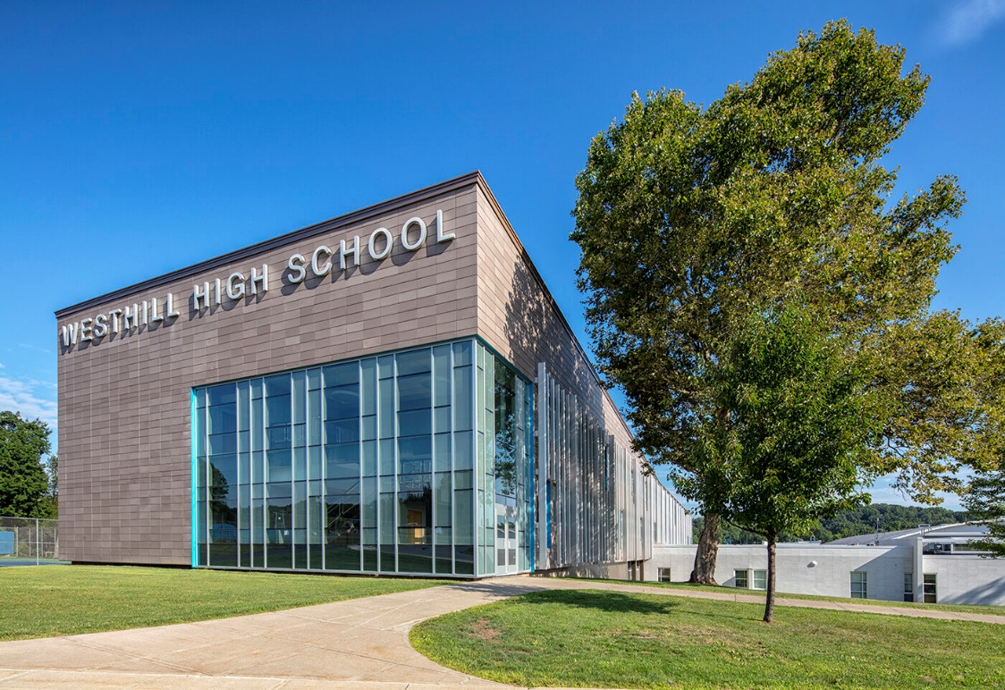

MINIMUM CAPACITY :-
The Minumum intake capacity
of students is between 350-620
children

LIBRARY :-
The Libarary is Available.

CANTEEN:-
The Canteen Facility is Available.

BOARDING :-
No availablility of boarding.

SPORTS :-
There are different categories
sports available.
Girls Volleyball
Boys Volleyball
Football

WESTHILL SENIOR HIGH SCHOOL
SYRACUSE - SCHOOL

School Detail :-
Westhill Senior High School is a public high school located in the western suburbs of, and immediately adjacent to, the City of Syracuse, New York. It serves grades 9 through 12, primarily from the neighborhood of Westvale, as well as portions of the Onondaga Hill area.
Established in 1963 as Westhill Junior-Senior High School serving grades 7-12 at the time, Westhill High School maintains a local reputation in the Syracuse area for having a high graduation rate, a large percentage of graduates attending college, and a successful athletic program.

